Steve Marsden
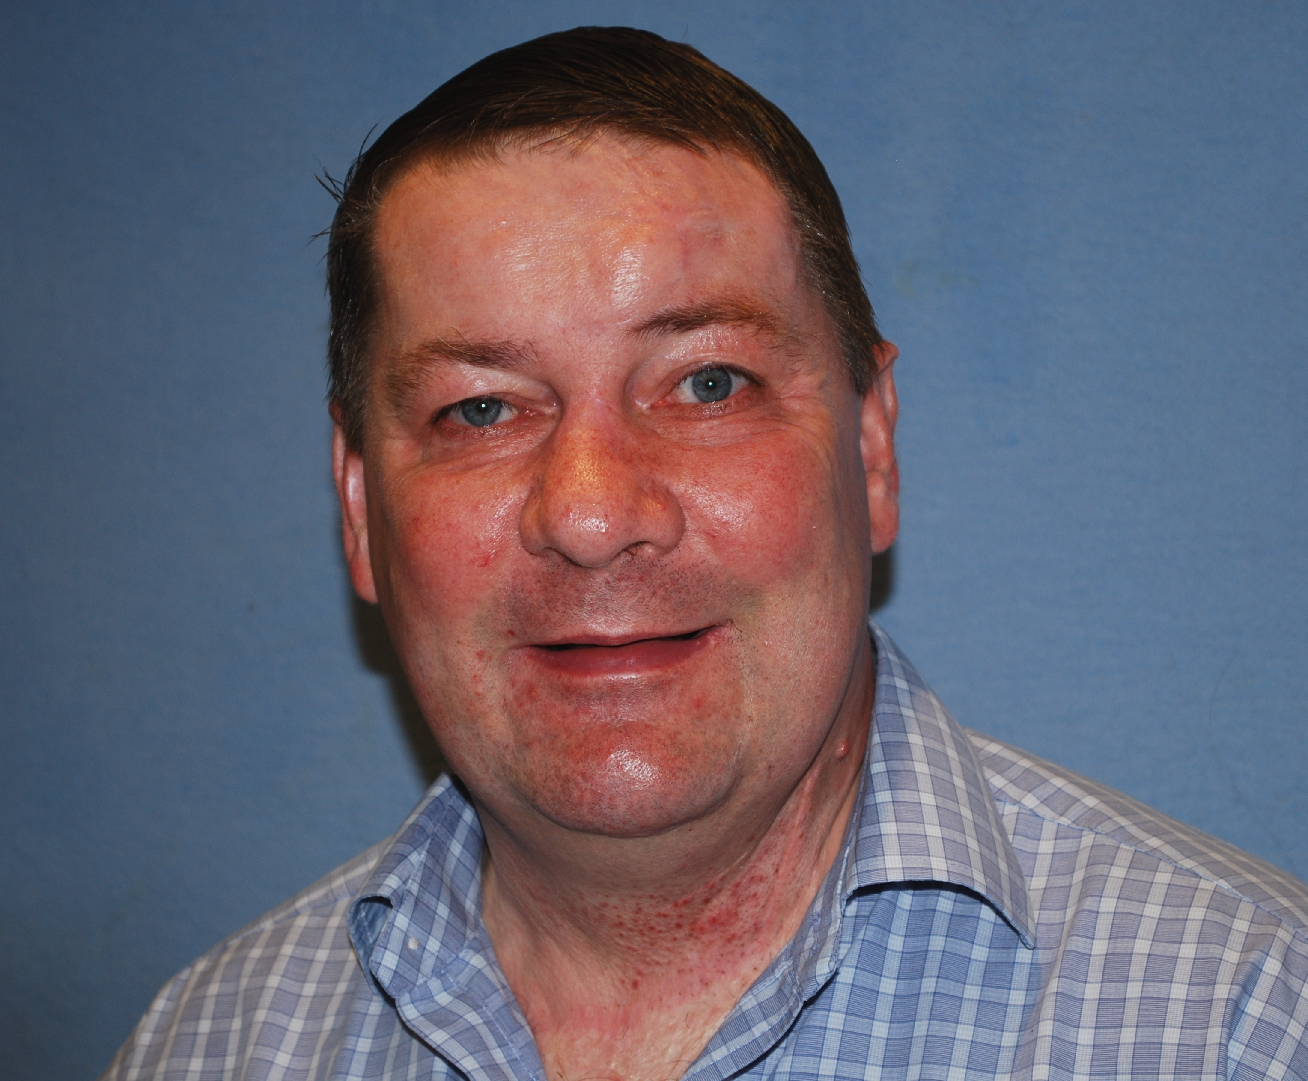

Angela & Steve Rogers
We have known Steve about 30 years. Our earliest memory was when he came over for an evening meal before a home group meeting. On this occasion our youngest child Michael, age 2 appeared in the lounge with his potty on his head. All I remember was the laughter all round, Steve loved to be included in family life!
He was missed when he attended St Andrews Chorleywood for some time. It was good when he returned to Fairfield.
He was always such a great encourager always asking after the wellbeing of others, even up to his last Friday when I met him at the coffee shop. He was concerned about my health as I wasn’t at house group that previous week. He had a wonderful caring nature.
Steve was a great cook and always keen to help others in need, I remember delivering a fantastic lasagne once for friend who was unwell.
Through all his health challenges his faith shone through and his testimony of God’s care on his life was evident to all.
It was so good to be with Steve on his 61st birthday to share in the enjoyment of his birthday cake. Steve was loved by many and we will miss him.
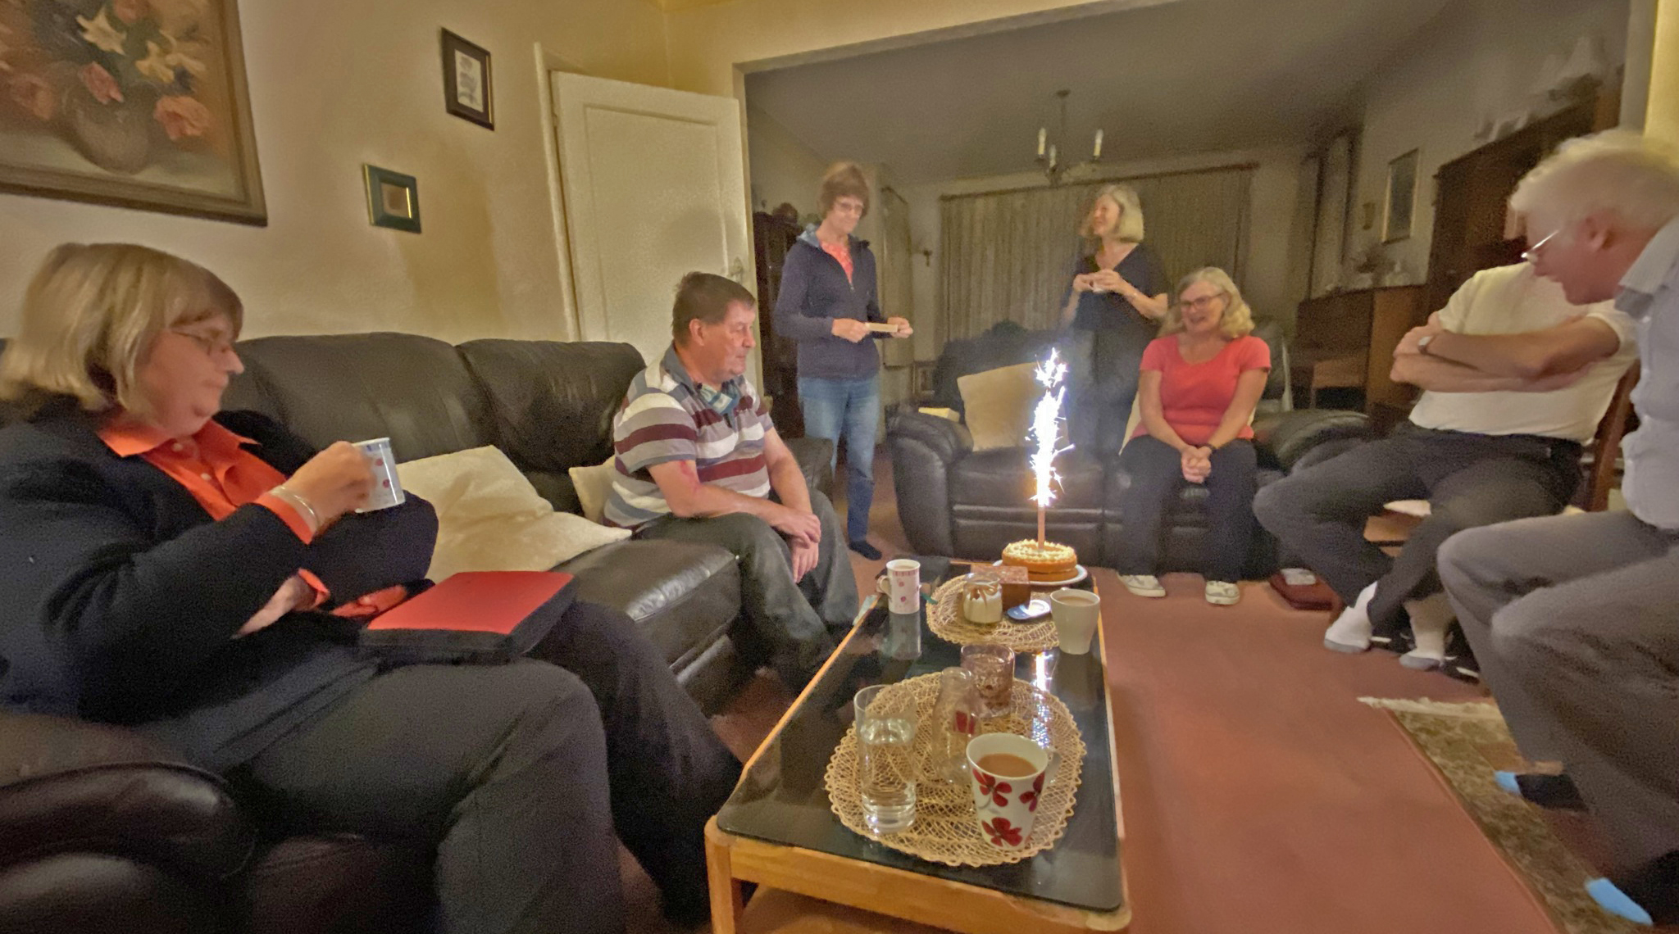

Chris & Lucy Reveley

We met Steve quite soon after Lucy and I came to Fairfield and we got to know him really well through our House Group as well as seeing him on Sundays. Later I’d see him often during the week when he came to Wednesday Fellowship or dropped in to Fairfield after shopping in Joel Street. We drove Steve to the last residential Church weekend away near High Wycombe which was a real holiday for him; had a Christmas Day together; and once, when his dear friend Andrew wasn’t able to accompany him, I went to London with him to meet one of his professors for a medical consultation.
Steve was one of the most determined (stubborn?) people I have ever met. Despite so many physical and mental health challenges Steve got on with life and enjoyed life and nothing could deter him from doing things he had decided to do. He did this both by his very strong will and with a deep trust in God who loved him, cared for him and saved him.
Many of us have heard him share his trust in the ‘God who saves’ during or at the end of a Sunday service when he would speak out his story of what God had done for him.
Despite every reason he had for thinking about himself he was always asking after others and wanting to help and support others. When he prayed for you it was special and he really came into his own in House Group after the Bible Study was over when we shared together and prayed for each other.
Steve was very independent and yet also very grateful for the people around him (his GP, the Pembroke Centre, the professors and staff at the National Hospital for Neurology) who supported him remaining independent.
It is a great privilege to have known Steve and we will miss him – he was a caring friend, one of a kind, one of God’s special children and one who is now with the God who has saved him for all eternity, pain-free, at peace and full of joy.

Jon Fox

I know the road you walked was anything but easy
You picked up your share of scars along the way
Oh, but now you're standing in the sun, you've fought your fight and your race is run
The pain is all a million miles away
The only scars in heaven, they won't belong to me and you
There'll be no such thing as broken, and all the old will be made new
And the thought that makes me smile now, even as the tears fall down
Is that the only scars in heaven are on the hands that hold you now.

From 'Scars in Heaven' by Casting Crows.
Knowing Steve for over 25 years, through being in a house group together, church together, talking regularly Sunday by Sunday, I got to know Steve and although we probably saw only just a small part of what he went through on a regular basis with his health, his gratefulness to our Father for protecting him daily and his faith in Him shone brightly through.

The only scars in heaven are on the hands that hold you now Steve.

Chris & Neville Pearson

Steve had been a member of our house group for a number of years and always expressed his faith in and dependence on his Lord and Saviour Jesus. He recently celebrated his birthday and was quite touched when we produced a cake and gift.
He had complete trust that Jesus was with him and taking care of him wherever he went.
Steve was amazing in the way he bounced back after whatever happened to him… a fall, a seizure, an injury …he rarely let things get him down.
We will miss him as he always gave thanks to God and in that he encouraged us.

Jeffery Wilson

I can’t remember when Steve first came to our Church Fellowship at Fairfield, it’s such a long time ago! But throughout that time Steve always expressed his joy in the Lord and reminded us, with great thanks, of the wonder of God’s saving grace through Jesus, so freely given and accepted by Steve.
Steve was a wonderful example to us of coping with severe health challenges, and through all that he faced he never stopped giving thanks to God for His love and care.
Steve will be greatly missed by us all, and we too give thanks to God for knowing Steve and his faith.

Candy Crane

Steve will be missed greatly and remembered fondly by me and my family. He was such an example of kindness, caring, bravery, love and joy. Though there were many dark spots in his life - he held on tight to his faith and to the saving grace that he knew in his heart to be the truth.

Fairfield will not be the same without him. Thank you Lord that me and my family were able to know this amazing person.
Nadia Kajenthiran

We have lost a friend. A friend who trusted in Jesus a lot. Every time I remember Steve he is saying - 'God is with me, God is good."

Steve was a respectable human being. He knew the value of the Word. He had a big smile when he talked of how the Lord rescued him so many times - Jesus, his saviour, how amazing you are.

I am sure Steve is at peace with you. Steve was in the same house group as me. He was cheerful and his testimony about Jesus was inspiring and will continue to live in my memory.

Steve was a gentleman. We loved him and we will never forget him.

Anne & Les Howcroft

Steve - he had sunny days and down days. The down days were not surprising with the number of health issues he contended with. But on sunny days you could not find a more lovely guy.

He was so caring of others - 'are you SURE you're alright?' He was full of warmth and his face would light up when telling of his latest mouth watering culinary creations. He was close to God and confident that God loved him and kept him safe.

Steve - we miss you!

The Petrovic family

Steve was always such a gentle soul and we admired his fervent faith in the Lord no matter what he faced. Steve enjoyed sharing his love of cooking with Emma and they would often bump into each other on her walk up Joel Street to Fairfield over the years.

We give thanks for Steve’s love of the Lord, May he rest in peace.

Martin Wilson

There will be an empty silence at the end of Fairfield services now, without Steve to fill the space with his heart-felt exclamations of faith and assurance. It was always a joy to hear Steve tell of his awareness of God’s presence with him through his life. He was certainly happy to tell others about it.

His life was not easy, and although he had some very low moments he also had many stories to tell of how he had survived extremely dangerous situations brought on by his epilepsy.

I feel he had a strong gratitude for God’s saving grace - which saved him both in body and spirit. Steve was resilient, determined, strong.

I also remember his humour in brighter times when he wasn’t so dulled by medication, his love of cooking and gardening… I thank God for his life - I will miss him.

